Branding Document

LOST MEDIA

SEM 3 Media Design

**Introduction** 3

ABOUT THE BRAND NAME 3

**Brand Strategy** 4

OUR MISSION 4

OUR VALUES 4

**Brand Positioning** 4

UNIQUE SELLING PROPOSITIONS 4

**Brand Identity Elements** 5

TYPOGRAPHY 5

COLORS 5

**Logo and Logo Elements** 6

LOGO 6

COLOR 6

TYPOGRAPHY 7

STRIPES 7

**Brand Voice and Tone** 8

OUR BRAND VOICE 8

CHARACTERISTICS 8

# **Introduction**

In this document we will address the core elements that represent Lost Media’s identity. From retro-inspired visuals to our nostalgic tone, we will address different design choices we made to make Lost Media unique. This guide will show our values, mission and vision.

## ABOUT THE BRAND NAME

1. **Brand Name: Lost Media**

* Reflects our commitment to use vintage media in a modern creative way.

1. **Meaning and Interpretation**

* “Lost Media” represents forgotten and nostalgic media forms, Combining past aesthetics with modern solutions.’

1. **Playfulness**

* The name provided for curiosity, inviting users to rediscover old media in modern and fresh ways.

1. **Memorability**

* The name “Lost Media” stands out due to its connection to nostalgia being instantly recognizable

1. **Versatility**

* The concept of “Lost Media” can be easily used across a wide range of designs, allow flexibility in branding and storytelling.

1. **Modern infused with Retro**

* Balancing retro with modern design trends, making it appealing for both vintage and modern generations.

# **Brand Strategy**

## OUR MISSION

At Lost Media we aim at creating something that will stay in the future. We create designs that will last centuries and can be called timeless. Our mission is to preserve and celebrate the past while pushing the boundaries of innovation. Finding the perfect middle between being classic and innovative, we show our clients and audience what it means to be iconic and to be remembered.

## OUR VALUES

1. Push ourselves to think outside of the box.
2. Get the most of this experience and the company.
3. Work with clients that want to make change and aim to be The Change in the world, while we help them.
4. Explore new horizons and learn even more about innovative technology.

# **Brand Positioning**

We at Lost Media position ourselves as assertive and bold studio, trying to break the cycle of fleeting and rapid designs. Our main goal is to create for people who bring new technologies and at the same try to remain in time.

## UNIQUE SELLING PROPOSITIONS

* **Diversity of characters-** every member in the company is unique. We all come from different backgrounds and see the creative world in our own way
* **Media Expertise**- all of us have different talents and together we complete them. We have experience in photography, branding and design, programming and UX research.
* **One of the few**- we are one of the few who are trying to release something that will last through times

# **Brand Identity Elements**

## TYPOGRAPHY

In our branding we chose to have San-serif fonts as they are modern and timeless as our values as well as versatile and adaptable to the time. We use as Primary font “New Amsterdam”- for the text in our logo. Out secondary font is “Outfit” which we for regular text.

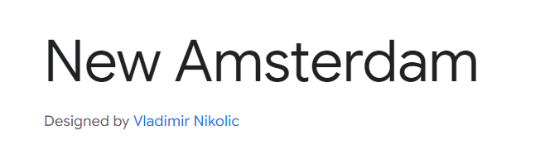

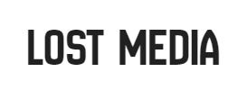 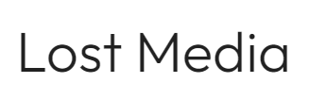

## COLORS

In our choice for colors, we went for a retro vibe. We got inspired by the old VHS tapes, but specifically those from the 80’s. Now we have:

* Turquoise – HEX: #55A7A5- Retro
* Yellow- HEX: #EFB73E- Energy
* Orange- HEX: # E96429- Young
* Red- HEX: #E8192D- Assertiveness

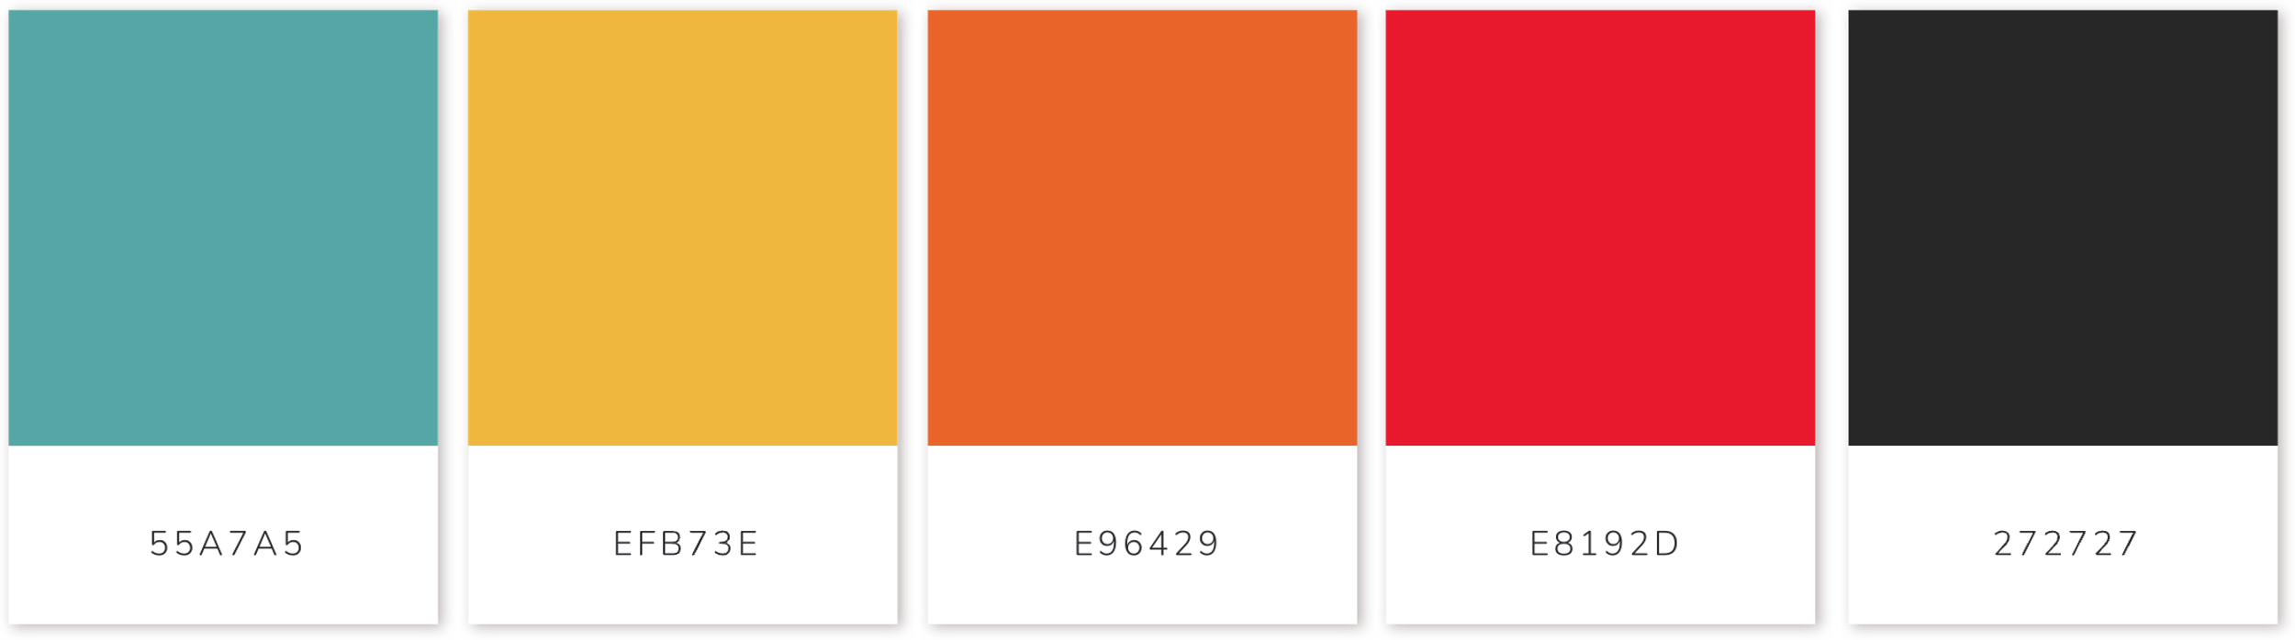

# **Logo and Logo Elements**

## LOGO

Our logo perfectly represents what we try to show and convey to our audience. Simple and timeless look with the perfect retro combination for the colors- just enough to spark that memory of the past media.

## COLOR

Our logo is versatile. It can be used on black and on white backgrounds. For even more freedom we made it transparent so it can go on every poster, website or other media.

## TYPOGRAPHY

The font used in our logo is sans-serif – “New Amsterdam”, giving this retro feel.

## STRIPES

The stripes used in the logo are the touch of the logo. The soft-edged stripes give this modern and approachable look and feel. Combined with the chosen color palette it takes your mind back in the 80’s with the VHS tapes.

Figure 1 Logo with white background

Figure 2 Logo with black background

Figure 1 Logo transparent with black font

# **Brand Voice and Tone**

## OUR BRAND VOICE

Our brand has a *Classic, Timeless, Retro, Daring and Assertive* tone of voice. We are trying to represent ourselves as young and creative designers who value the bases of design and the work of designers in the past.

## CHARACTERISTICS

* **Classic**- trying to use iconic design techniques and styles
* **Timeless-** we strive to show the world again that logos can live through the years without a need of making them relatable for the current years
* **Retro**- trying to appeal to the older generations as well as the younger one
* **Daring**- we are not afraid to experiment with the design and show that the past was a great place for design
* **Assertive**- we try to show and prove to our audience and clients that retro can be something different from old-fashioned and outdated

# **Brand Implementation Examples**

